# Data Based Modeling:

**Noun List:**

|  |  |  |  |
| --- | --- | --- | --- |
| **No.** | **Noun** | **P / S** | **Attributes** |
| 1 | ISRT | P |  |
| 2 | Research Journal | P |  |
| 3 | Demand | P |  |
| 4 | Suggestion | P |  |
| 5 | Category | S |  |
| 6 | Annual budget | P |  |
| 7 | Bill | P |  |
| 8 | Accountability | P |  |
| 9 | Borrowing | S | 87, 45, 48, 15 |
| 10 | Internal reference | P |  |
| 11 | Researcher | P |  |
| 12 | Research | P |  |
| 13 | Output | P |  |
| 14 | Certificate | P |  |
| 15 | Date | S |  |
| 16 | Marksheet | P |  |
| 17 | Pension | P |  |
| 18 | Pending book | P |  |
| 19 | Statement | P |  |
| 20 | Mobile | P |  |
| 21 | Working duration | P |  |
| 22 | Metadata | P |  |
| 23 | Audit | P |  |
| 24 | Academic publishing | P |  |
| 25 | Account | P |  |
| 26 | Library Management System (LMS) | P |  |
| 27 | User | S | 32, 33, 40, 41, 44, 70, 80,91 |
| 28 | Student | S | 36, 37, 38, 39 |
| 29 | Teacher | S | 42, 89 |
| 30 | Staff | S | 42, 89 |
| 31 | Faculty | P |  |
| 32 | Name | S |  |
| 33 | Phone number | S |  |
| 34 | OTP | S | 33, 71, 15 |
| 35 | Verification | P |  |
| 36 | Roll number | S |  |
| 37 | Registration number | S |  |
| 38 | Session | S |  |
| 39 | Hall name | S |  |
| 40 | Email | S |  |
| 41 | Address | S |  |
| 42 | Designation | S |  |
| 43 | User ID | S |  |
| 44 | Password | S |  |
| 45 | Return date | S |  |
| 46 | Fine | S | 87, 103 |
| 47 | Payment | S | 33, 78,92 |
| 48 | Status | S |  |
| 49 | Notification | P |  |
| 50 | SMS | P |  |
| 51 | E-Library | P |  |
| 52 | Book PDF | S |  |
| 53 | Title | S |  |
| 54 | Author | S |  |
| 55 | Subject | S |  |
| 56 | Summary PDF | S |  |
| 57 | Review | S |  |
| 58 | Rating | S |  |
| 59 | Feedback | P |  |
| 60 | Smart search function | P |  |
| 61 | Filtering option | P |  |
| 62 | Borrowing request | P |  |
| 63 | Borrowing form | S |  |
| 64 | Classification number | S |  |
| 65 | Integrated library catalog | P |  |
| 66 | Availability | P |  |
| 67 | Waitlist | P |  |
| 68 | Eligibility | P |  |
| 69 | Queue | P |  |
| 70 | Role | S |  |
| 71 | Application time | S |  |
| 72 | Teacher priority | P |  |
| 73 | Return deadline | S |  |
| 74 | Fine policy | P |  |
| 75 | Library seal | P |  |
| 76 | Blacklist status | S |  |
| 77 | Cancellation notice | P |  |
| 78 | Mobile Financial Services (bKash, Nagad) | S |  |
| 79 | Transaction confirmation | P |  |
| 80 | Demerit point | S |  |
| 81 | Renewal | P |  |
| 82 | Borrowing record | P |  |
| 83 | Book purchase committee | P |  |
| 84 | Clearance | S | 48,76, 85, 86, 87, 14 |
| 85 | Request | P |  |
| 86 | Type | S |  |
| 87 | Form | S |  |
| 88 | Pending book | S |  |
| 89 | Department | S |  |
| 90 | Book | S | 52, 53, 54, 93, 94, 55, 64, 5,58,94 |
| 91 | Amount | S |  |
| 92 | Transaction ID | S |  |
| 93 | Price | S |  |
| 94 | Number of pages | S |  |
| 95 | Archive |  |  |

**Data Objects:**

|  |  |  |
| --- | --- | --- |
| No. | Data Objects | Attributes |
| 1 | User | Name, Phone no, Email, Address, User Id, Password, Role, Demerit Point, Amount |
| 2 | Student | Roll no, Registration no, Session, Hall |
| 3 | Teacher | Designation, Department |
| 4 | Staff | Designation, Department |
| 5 | Clearance | Status, Blacklist Status, Request, Type, Form, Certificate |
| 6 | Book | Book pdf, Title, Author, Number of Page, Price, Subject, Classification no, Category, Rating, Archive |
| 7 | Payment | Phone no, MFS, Transaction ID |
| 8 | OTP | OTP no, Phone no, Time, Date |
| 9 | Borrowing_Details | Borrow Id, Borrow Date, Form, Return date, Status |

**Relations:**

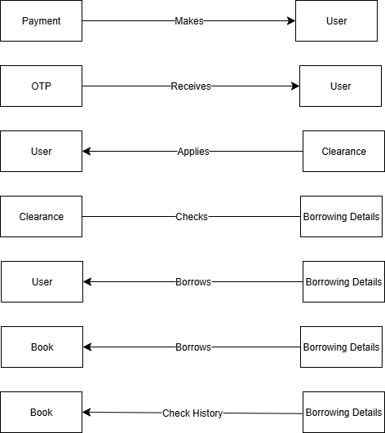**ERD:**

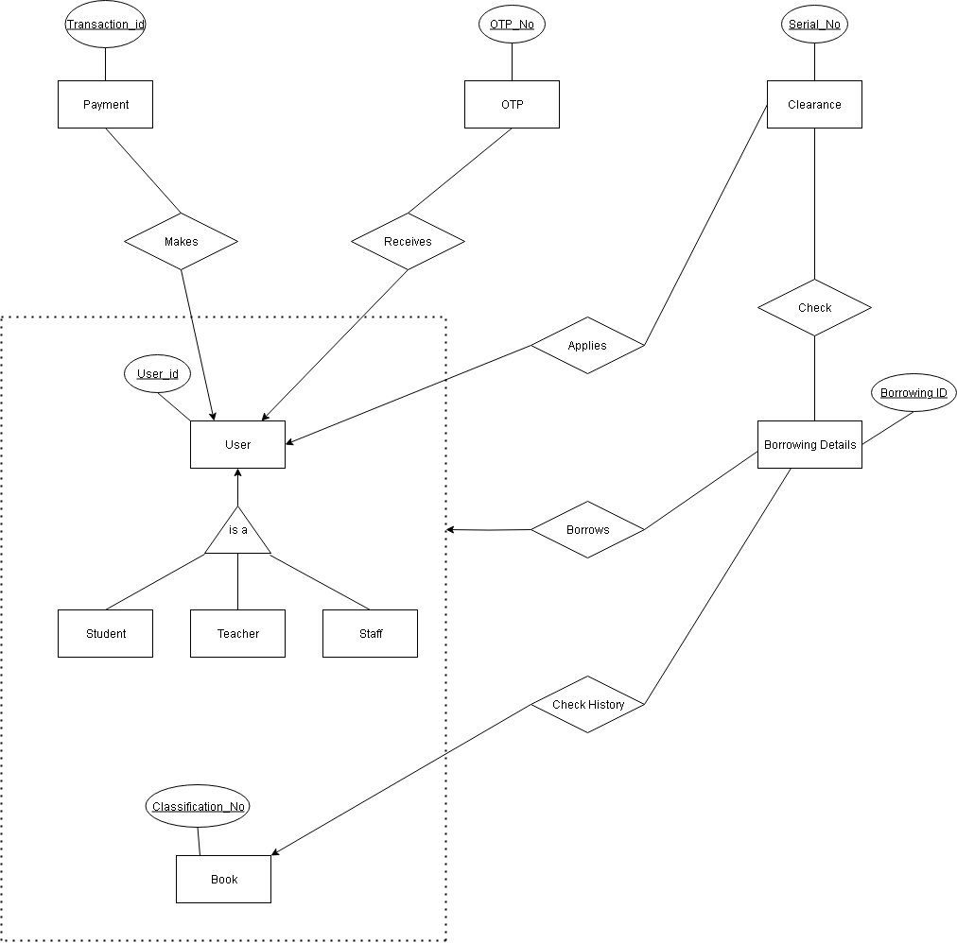

**Schema:**

|  |  |  |  |  |
| --- | --- | --- | --- | --- |
| No. | Entity Name | Attribute | Type | Description |
| 1. | User | User_Id (PK) | INT | Unique identifier for each user |
| Name | VARCHAR | Full name of the user |
| Phone_No | VARCHAR | User's phone number |
| Email | VARCHAR | User's email address |
| Address | VARCHAR | Residential address |
| Password | VARCHAR | Login password |
| Role | VARCHAR | Defines user type (Student, Teacher, Staff) |
| Demerit_Point | INT | Points deducted for violations |
| Amount | INT | Balance amount or dues |
| 2. | Student | User_Id (PK, FK) | INT | References User |
| Roll_No | VARCHAR | Student roll number |
| Registration_No | VARCHAR | Student registration number |
| Session | VARCHAR | Academic session |
| Hall | VARCHAR | Hall or dormitory name |
| 3 | Teacher | User_Id (PK, FK) | INT | References User |
| Designation | VARCHAR | Teacher's designation |
| Department | VARCHAR | Department of the teacher |
| 4 | Staff | User_Id (PK, FK) | INT | References User |
| Designation | VARCHAR | Staff designation |
| Department | VARCHAR | Staff department |
| 5 | Clearance | Serial_No (PK) | INT | Unique clearance number |
| User_Id (FK) | INT | References User |
| Status | VARCHAR | Clearance status |
| Blacklist_Status | BOOLEAN | Whether the user is blacklisted |
| Request | VARCHAR | Clearance request type |
| Type | VARCHAR | Type of clearance |
| Form | VARCHAR | Clearance form |
| Certificate | VARCHAR | Related certificate |
| 6 | Book | Classification_No (PK) | INT | Unique classification number |
| Title | VARCHAR | Book title |
| Author | VARCHAR | Book author |
| Subject | VARCHAR | Subject area |
| Book_PDF | VARCHAR | PDF file path or link |
| Category | VARCHAR | Book category |
| Rating | INT | Book rating |
| Price | DECIMAL | Price of a Book |
| Number_of_page | INT | Number of pages of a book |
| Archive | BOOLEAN | Whether book is archived |
| 7 | Payment | Transaction_Id (PK) | INT | Unique transaction identifier |
| User_Id (FK) | INT | References User |
| Phone_No | VARCHAR | Payment phone number |
| MFS | VARCHAR | Mobile financial service used |
| 8 | OTP | OTP_No (PK) | INT | One-time password identifier |
| User_Id (FK) | INT | References User |
| Phone_No | VARCHAR | User's phone number |
| Time | VARCHAR | OTP generation time |
| Date | DATE | OTP generation date |
| 9 | Borrowing_Details | Borrow_Id (PK) | INT | Unique borrow identifier |
| User_Id (FK) | INT | References User |
| Classification_No (FK) | INT | References Book |
| Borrow_Date | DATE | Borrowing date |
| Return_Date | DATE | Book return date |
| Status | VARCHAR | Status of Borrowing |
| 10 | Check | Serial_No (PK, FK) | INT | References Clearance |
| Borrow_Id (PK, FK) | INT | References Borrowing_Details |